**CHAPTER I**

**INTRODUCTION**

This chapter presents the background of the study, historical background, organizational chart, organizational function, and statement of the problem, objectives of the study, scope and limitation and definition of terms of the study.

* 1. **Background of the Study**

The growth of technology has contributed a lot to the continued progress of all classification of industry. However, some sectors today seem to be left behind in adapting the use of different methods to have progress on their part.

Computerization is a control system that manages processes in the industrial workplace. It reduces human errors and processing time thus, it can boost productivity and result into a high quality of product process. This can result in a system well integrated process that can perform much faster and more accurate than the manual system.

Tourism is a major income contributor. The expenditures made by the tourists mostly come from accommodation, foods, shopping and transportation.

Shopping in terms of souvenir is one of the distinctive reasons why people travel to other places. It is the nature of humans, to have some form of items representing where they have travelled. It is a badge of honor that indicates that the person has already made that journey or visited a certain place. During vacations and trips, tourist will spend money in terms of entertainment, accommodation, transportations, other services and shopping.

One of the popular activities during vacations and trips is shopping. Therefore, it is important to have a better understanding of the reason why tourist buy souvenir in order to develop souvenirs that are saleable. This research focuses on respondents’ views of why they buy souvenirs and presents the findings for management to utilize.

Computerization is a control system that manages processes in the industrial workplace. It reduces human errors and processing time thus, it can boost productivity and result into a high quality of product produce. This can result in a system well integrated process that can perform much faster and more accurate than the manual system.

“Binuatan Creations’ Tour guides & Drivers Commission System “is appropriate for use of the cashier, to easily determine the total of the items bought by tourists at the same time, give a 6% of the amount purchased to tour guides and drivers as a commission.

The flow of our Manual System is first, Drivers/Tour guides must sign their attendance then Second, summing up the total items sold by the customers that they've bought in Binuatan Creations. next, cashier will simply put the driver's/tour guide’s name in Microsoft excel one by one. then cashier is going to compute the total 6% share of the driver/tour guide. then the transaction will be printed out to be used as a receipt, and served as an evidence that they really bought a customer and it'll be put in envelope and will be release on 2nd week of December.

1.1.1 Historical Background

One of many difficulties we have encounter in Manual System is typing names came from the logbook one by one and because it was hand written, sometimes cashier can't clearly understand their writing resulting in creation of multiple accounts caused by misspelled names.

Binuatan Creations was established last January 22, 2002. Sta. Monica is a barrio in Puerto Princesa City, the capital of Palawan. A visit to this place would not be complete if one misses to drop by Binuatan Creations. A handicraft shop know for handwoven place mats, table runners, wall covers, and window blinds. Binuatan Creations is famous for products made from fibers, among them amumuting, vetiver grass, tambo-tambo, florica, tikog, buntal, ginit, talahib, and mangrove grass. They are much sought for the texture and color that provide the prime and unique characteristics of the products of Binuatan Creations. Eva Valledor or “Bang,” as her friends call her, is the young manager and life of Binuatan Creations.

Bang’s search for the center’s strategic location ended up to utilizing her uncle’s house in Sta. Monica who by that time was looking for livelihood oppportunities for his fellow members of Dating Daan, a religious evangelical group. Acoording to her uncle, some members of this group missed their church services because they did not have cash for their transportation expenses. From the P50,000 initial capital sourced out from her close friends, the first cry of Binuatan Creations was heard. Binuatan is derived from the Cuyunon dialect which means creation.

1.1.2 Organizational Chart

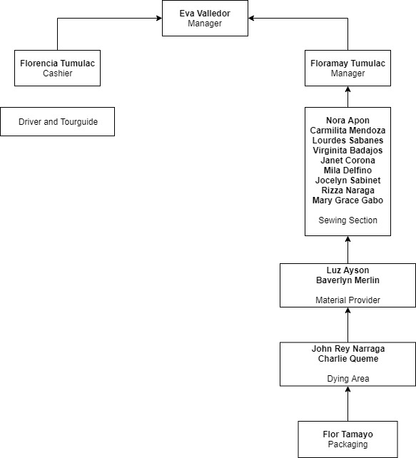

1.3 Organizational Functions

**Binuatan Creations**

|  |  |
| --- | --- |
| **Position** | **Job Description** |
|  |  |
| **Manager** | Head of Binuatan Creations that is in charge in a business. |
| **Cashier** | Handling and checking all the cash and Maintaining monthly, weekly and daily report of transactions. |

**PERSONAL STAFF**

|  |  |
| --- | --- |
| **Sewing Section** | Focused on providing a high quality service and customer satisfaction with traditional craftsmanship tailored to perfection. |
| **Material Provider** | Provide material like fibers, amumuting, vetiver grass, tambo-tambo, florica, tikog, buntal, ginit, talahib, and mangrove grass to the staff of Binuatan Creations. |
| **Dying Area** | The post-harvest system during which the product is rapidly dried until it reaches the "safe-moisture" level. |
| **Packaging** | A finished product contained in a unit that is suitable for immediate installation and operation. |

**1.2 Statement of the Problem**

This study entitled, Binuatan Creations’ Tour Guides and Drivers Commission System, is designed because the Binuatan Creations’ is only used manual system. The following difficulties has been revealed within the manual system used:

1. Manuel system cannot surely determine where error occur between the admin and user.
2. The manual system is time-consuming when finding documents and inputting names from the log book.
3. There are difficulties in finding records or documents because the manual system is not organized.
4. The existing system uses handwriting which is not understandable.
   1. **Objectives of the Study**

1.3.1. General Objectives

As its general objective, this study aims to propose a software system design that would provide a reliable and user friendly progressive quality computerized system for the Binuatan Creations’ of Puerto Princesa City.

The use of system is important to monitor, give more information, help to save time and control the situation.

1.3.2 Specific Objectives

The specific objectives of the proposed friendly-user software are as follows:

1. To create a system that would easily determine where error occur between the admin and user;
2. To create a system that would minimize time consuming when finding documents and inputting names from the log book;
3. To create a system that is organized and easy to use.
4. To create a system that would easily monitor the movement of each document during its lifecycle and reduce the extended time to find documents;
   1. **Significance of the study**

This study will contribute to develop a Commission System of Binuatan Creations, Sta. Monica Puerto Princesa City a computation item’s total amount for commission. Binuatan Creations’ Tour Guides and Drivers Commission System is an example of a new technology that files the record and easily compute the commission total for Tour guides and Drivers.

This study gives the following benefits:

*To the Admin of the Binuatan Creations of Puerto Princesa City:* The system will give them a good service for commission system. The system will help the Binuatan Creations’ of Puerto Princesa to minimize worries and stress in finding document. The use of this system is important for the documents especially to the admin of Binuatan Creations’ it gives more information, help to save time and control the situation.

*To the User of the system of Binuatan Creations:* It will give information system capable of finding the paper trail of documents. This effective and convenient system will replace their current method of using log book which give difficulty in finding documents. The system will improve in turn of the process for having sending and receiving documents.

*To the Proponent and ACLC Institution:* The results of this study will help to know the strengths and weaknesses of the researcher in producing a software system that would help the Binuatan Creations of Puerto Princesa City. This will provide response as to the brilliance of AMA Computer Learning Center instructional system in producing future graduates.

*To the Future Researcher’s:* This study will serve as a source of information that may used as a guide, reference and/or a related literature in accompanying studies of a similar nature.

**1.5 Scope and Delimitation**

This study focuses on Binuatan Creations’ Tour Guides and Drivers Commission System for them to easily compute the commission of a tour guides or drivers that bring guest in Binuatan who buy their product. The user of this system will be the Cashier of Binuatan.

This proposed system is designed only to Binuatan Creations’ Guides and Drivers Commission System in which analyst offers solution on current problems encountered.

**1.6 Definition of Terms**

For the better understanding of this study the following terms were

defined operationally and theoretically:

**Admin.** This term refers to the administrator who is in charge in the main server.

**Commission.** A formal written warrant granting the power to perform various acts or duties.

**Drivers.** The operator of a motor vehicle

**Manual.** This term refers to the action done by the client when using ball pen and writing on a log book.

**Tour Guide.** Person who takes people on trips through an area and explains the interesting details about it.

**User.** This term refers to the operator/employee using the system.

**CHAPTER III**

**ARCHITECTURAL DESIGN**

This chapter presents the description of the current system, and description of the proposed system and the proposed system flowchart of the study.

**2.1 Description of the Current System**

The Binuatan Creations’ of Puerto Princesa uses manual methodwhich is usinglog book.

2.1.1 Current Data Flow System

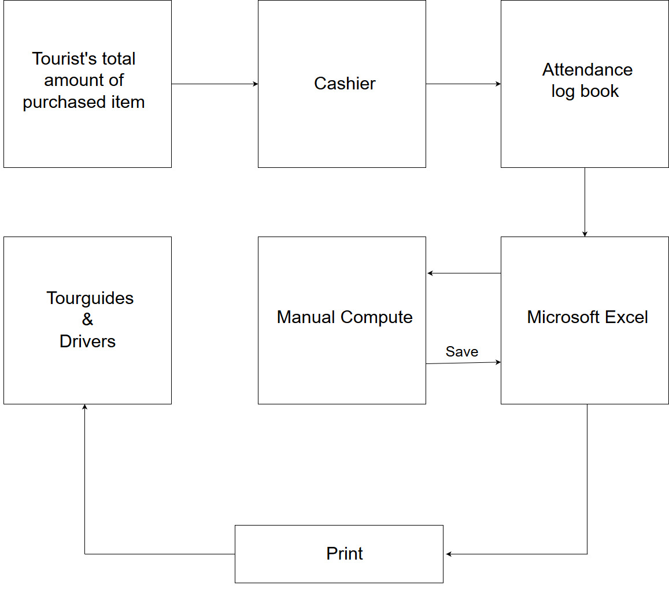**PROCESS OF THE MANUAL SYSTEM**

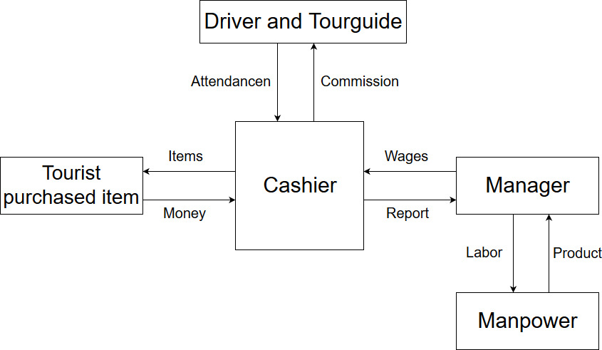

**2.2 Description of the Proposed System**

The system has two users: user and admin. In user, they cannot edit and delete but enable them to see and open the Record, Edit own account, View about, add amount, Open attendance system, print file, Convert Microsoft Excel file, reminder, message, and log out the system. Automatically, all the things that the user does in the system will generate a report to admin. In account modification, user can’t modify his/her account unless the admin do it. In admin, he/she can edit the user’s account. Admin can access all navigations in the system.

To log in the system, required to input password and username that is automatically modify if the Users is admin or user. If the username and password incorrect, the system will not generate but end up showing a red text “You have entered invalid username or password!” So it is important. If the user or admin forgets the password, he/she can recover it by going to “Forgot Password” button; the forgot password form has two inputs for username verification and security question, after filling up two inputs, the password will reveal with the button “Finish”. If you click the button, it goes back to login form to continue filling up the form.

In generating attendance scanner, you need to login first then you can press Scanner button in navigation bar, automatically open the attendance scanner. To enter amount from attendance you need to DoubleClick the name from attendance list.

2.2.2 Proposed System Flow Chart

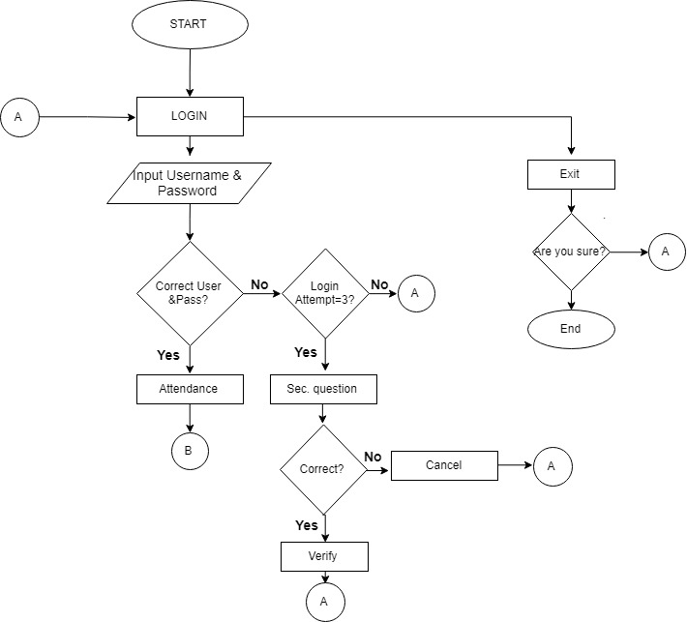

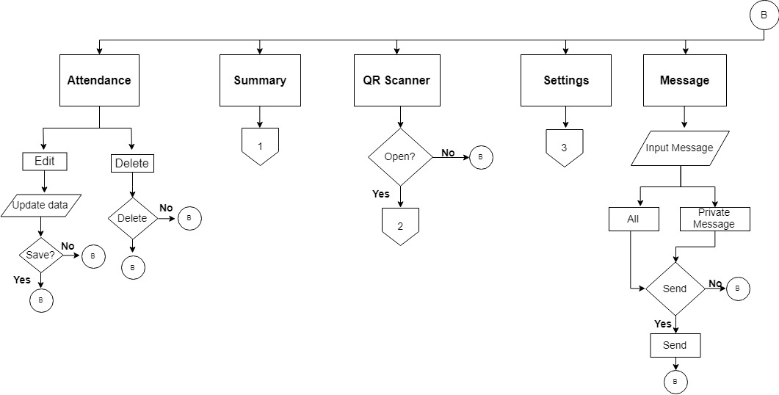

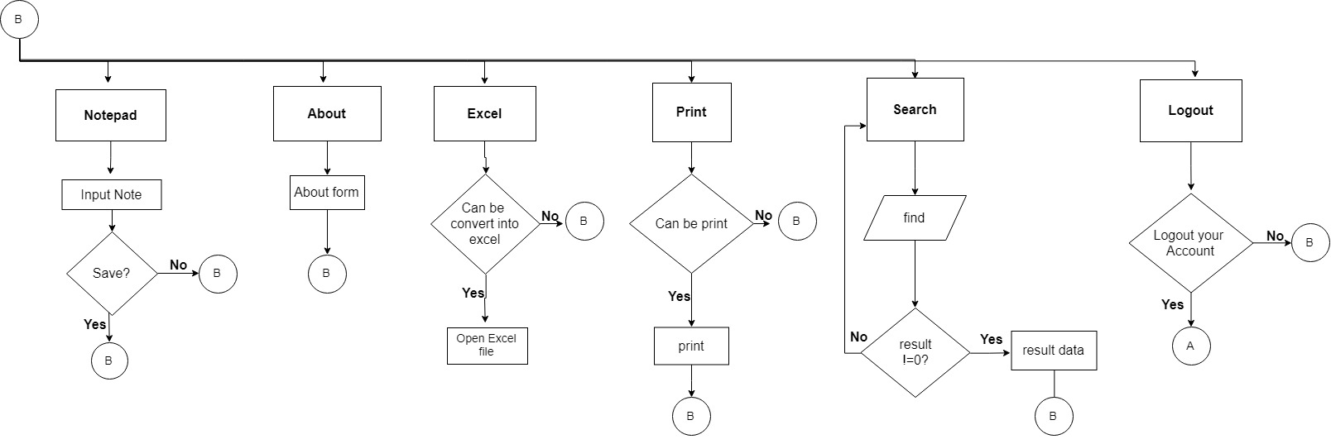

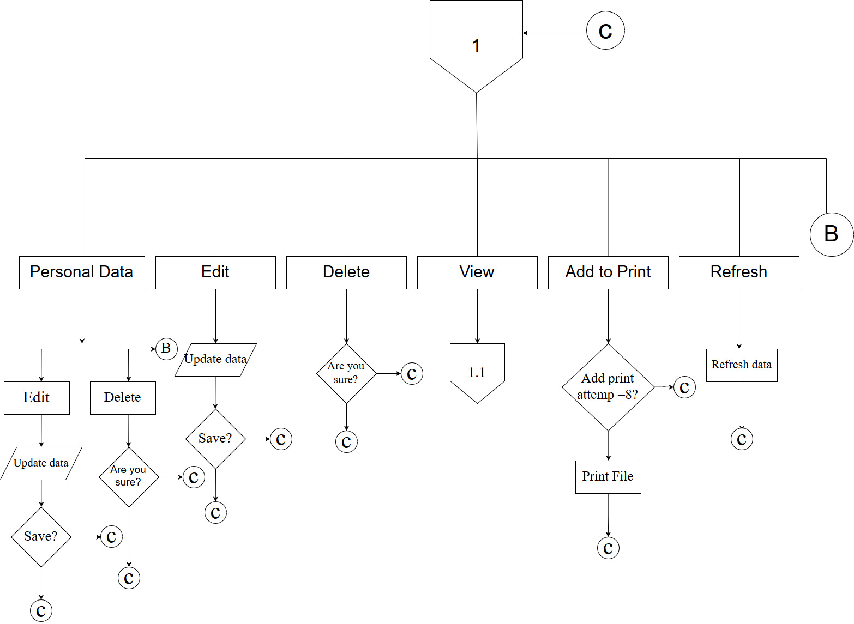

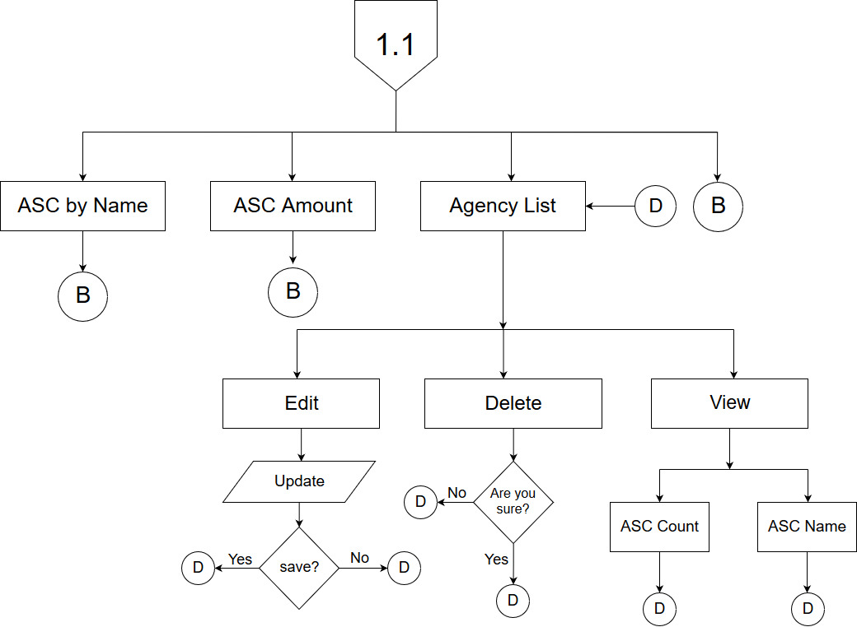

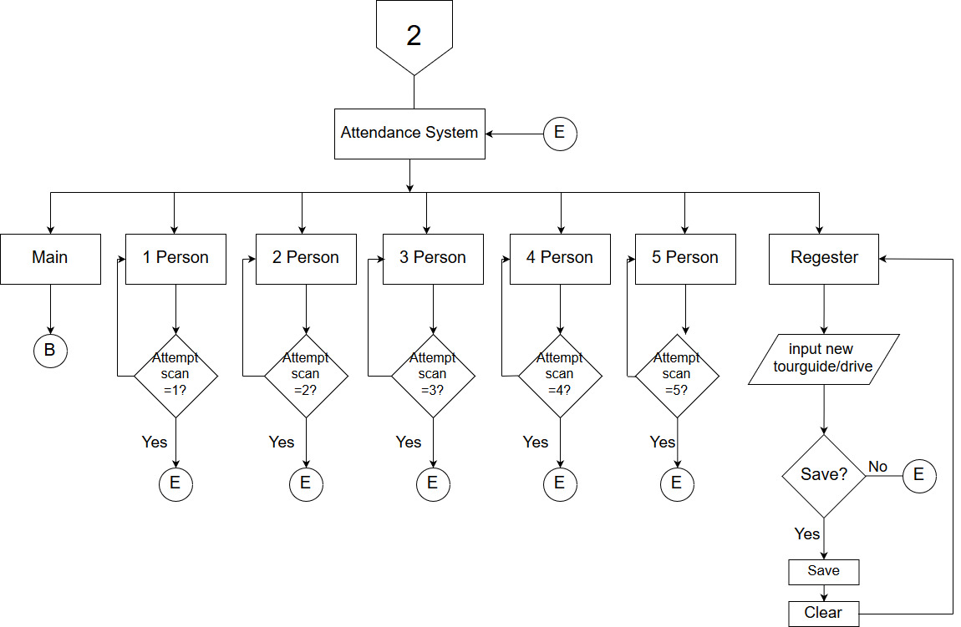

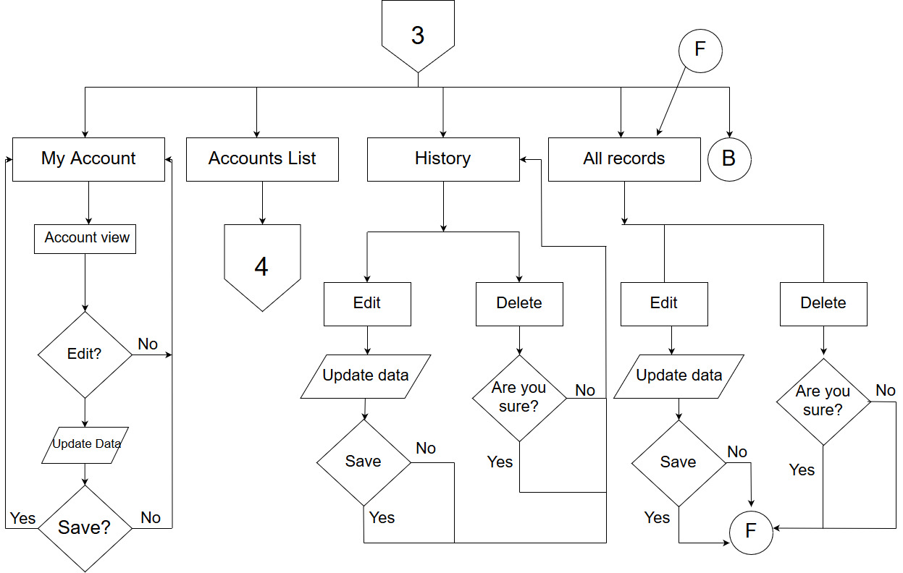

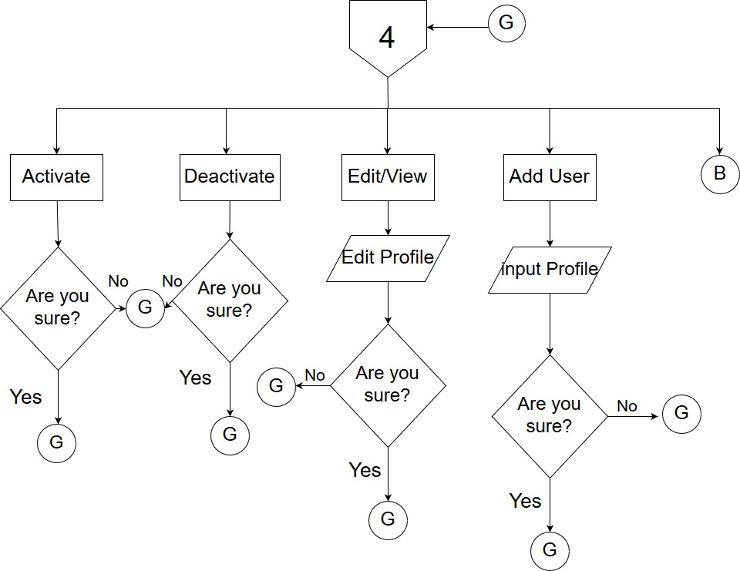

**CHAPTER III**

**SYSTEM DESIGN AND LAYOUT**

This chapter presents the system requirements, software requirements, cost analysis and the benefits analysis of this study.

**3.1 System Requirements**

The proposed system will need the following:

3.1.1 Software Requirements

1. Windows 7 or higher

3.1.2 Hardware Requirements

1. QR code sticker

2. QR code scanner

3.1.2 Cost Analysis

The use of pens and papers for gathering information manually are sometimes costly than expected, why? As times goes by, some of the specified products that needs are way too costly when summed up altogether.

The cost breaks down of the manual used system comprises:

|  |  |  |  |  |  |
| --- | --- | --- | --- | --- | --- |
| **Items** | **Year 2019** | **Year 2020** | **Year 2021** | **Year 2022** | **Year 2023** |
| Sign Pens | P 500.00 | P 530.00 | P 550.00 | P 650.00 | P 680.00 |
| Logbook | P 300.00 | P 350.00 | P 400.00 | P 350.00 | P 370.00 |
| Band paper | P 1,550.00 | P 1,600.00 | P 1,620.00 | P 1,650.00 | P 1,730.00 |
| Envelop | P 750.00 | P 850.00 | P 880.00 | P 900.00 | P 930.00 |
| **TOTAL** | P 3,100.00 | P 3,330.00 | P 3,450.00 | P 3,550.00 | P 3,710 |

Meanwhile, we’re proposing a system that is honestly way too costly than pens and papers that Binuatan Creations usually use in gathering information. But in the other hand, the said system can increase the chance of saving up thousands of peso if used.

The cost breaks down of the proposed system comprises:

|  |  |  |  |  |  |
| --- | --- | --- | --- | --- | --- |
| **Items** | **Year 2019** | **Year 2020** | **Year 2021** | **Year 2022** | **Year 2023** |
| System Cost | P 5,000.00 | 0 | 0 | 0 | 0 |
| Expenses | P 500.00 | 0 | 0 | 0 | 0 |
| Sign Pens | P 500.00 | P 530.00 | P 550.00 | P 650.00 | P 680.00 |
| Logbook | P 300.00 | P 350.00 | P 400.00 | P 350.00 | P 370.00 |
| Band paper | P 1,550.00 | P 1,600.00 | P 1,620.00 | P 1,650.00 | P 1,730.00 |
| Envelop | P 750.00 | P 850.00 | P 880.00 | P 900.00 | P 930.00 |
| **TOTAL** | P 3,100.00 | P 3,330.00 | P 3,450.00 | P 3,550.00 | P 3,710 |

The system costs P5000.00, because the system uses format which makes it more attractive and good looking. Also, it is user friendly and easy to understand. The expenses cost P500.00, because the proponent spent for food and vehicle fares in doing the research.

Furthermore, the said system will literally help Binuatan Creations on saving thousands of peso if they would adapt the use of proposed system instead of buying and replacing old medium of gathering tour guides and driver’s information. Moreover, it can really help them to secure data and won’t consume much time than they usually do.

|  |  |
| --- | --- |
| Proposed System | P 8,860.00 |
| Manual System | P 3,100.00 |

**3.3 Benefits Analysis**

The computerized system will benefit the Binuatan Creations’ of Puerto Princesa City in their transaction of documents. It is used to send and receive document with less time consumed and with speed that would save their time and effort.

The beneficiary of this system is the admin and user of Binuatan Creations’ of Puerto Princeesa City. It would help to view or find document in a short period of time which determines conflict, less stress and worry.

**CHAPTER IV**

**CONCLUSION AND RECOMMENDATION**

This chapter presents the conclusion and recommendation of the study which were collated after the conduct of the research.

**4.1 Conclusion**

Baesd on the result of the study, the following conclusions were drawn:

1. We conclude that proposed system can determine where error occur between the admin and user;
2. We conclude that proposed system is lessen the time consuming when finding document
3. We conclude that proposed system is organized and easy to use; and
4. We conclude that proposed system can easily monitor the movement of each document during its lifecycle and reduce the extended time to track documents;

**4.2 Recommendation**

Based on the conclusion, the following recommendations are offered for consideration:

1. It is recommmended to the admin and user to adapt and fully maintain this system
2. To the future researchers, it is recommended to have more secured database and enhance the system.

**BIBLIOGRAPHY**

J.Aranca&K.Ducao., Barcode identification System for the Faculty and Staff of AMA Computer Learning Center,.ACLC Palawan Branch,.February2011

J.Ordiz., Automated Grading System of San Rafael High School,. ACLC Palawan Branch, March2010

M.Abdulla.,Document Tracking System of the City Government of Puerto Princesa City., ACLC Palawan Branch,,.April2016



**APPENDICES**

**APPENDICES A**

**PRINT SCREEN**

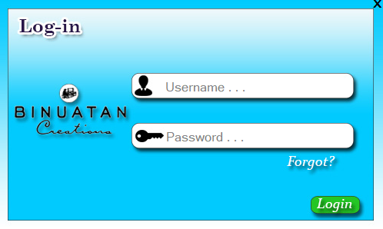

**Login**



**Loading**

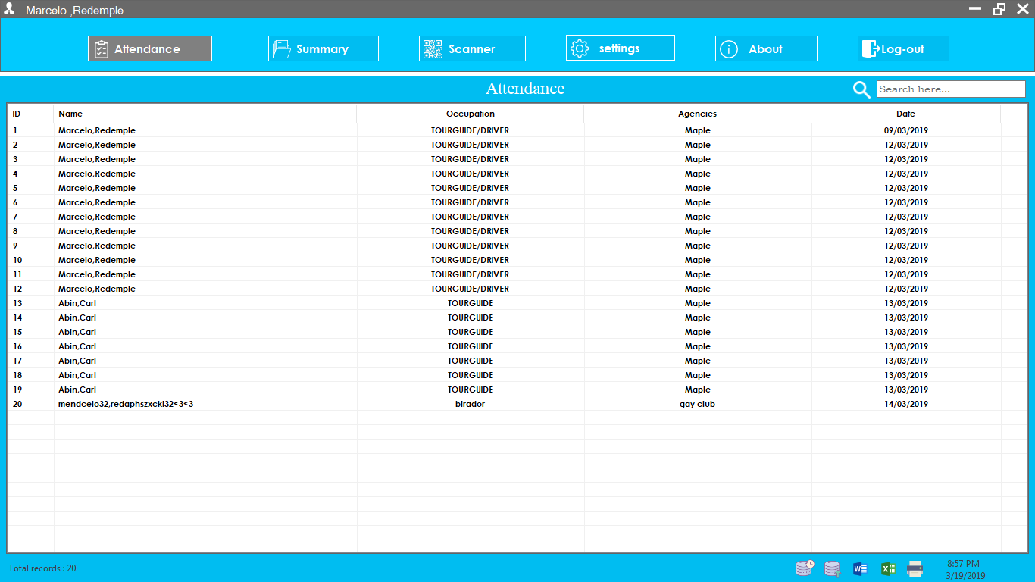

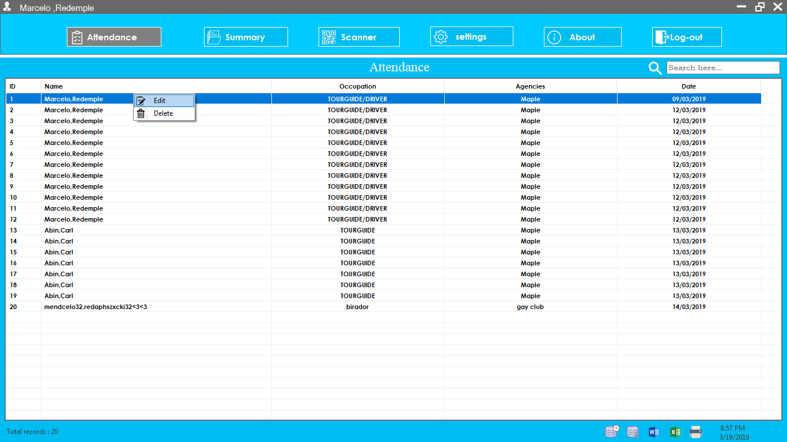**Attendance list**

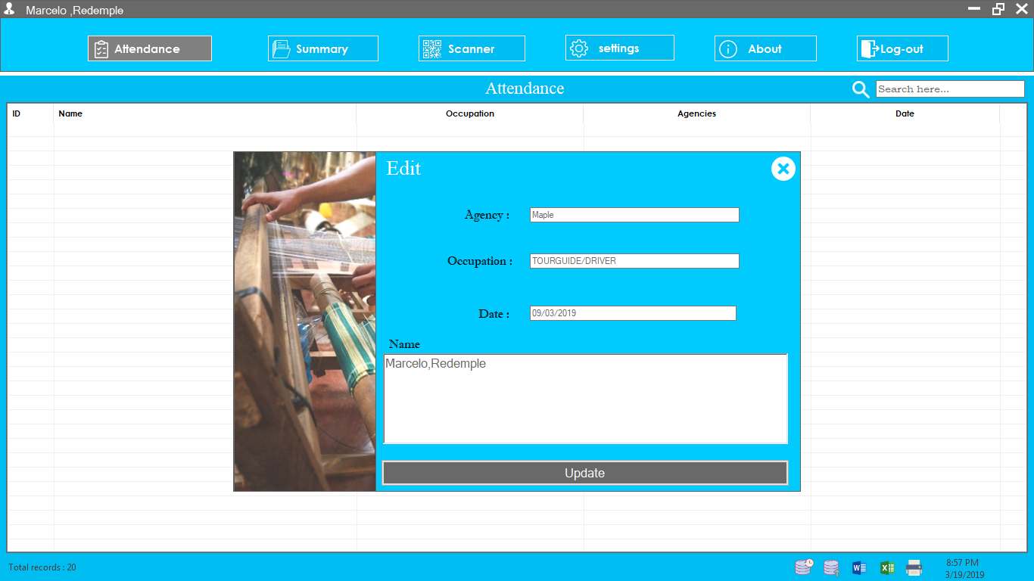

**Edit and Delete Attendance**

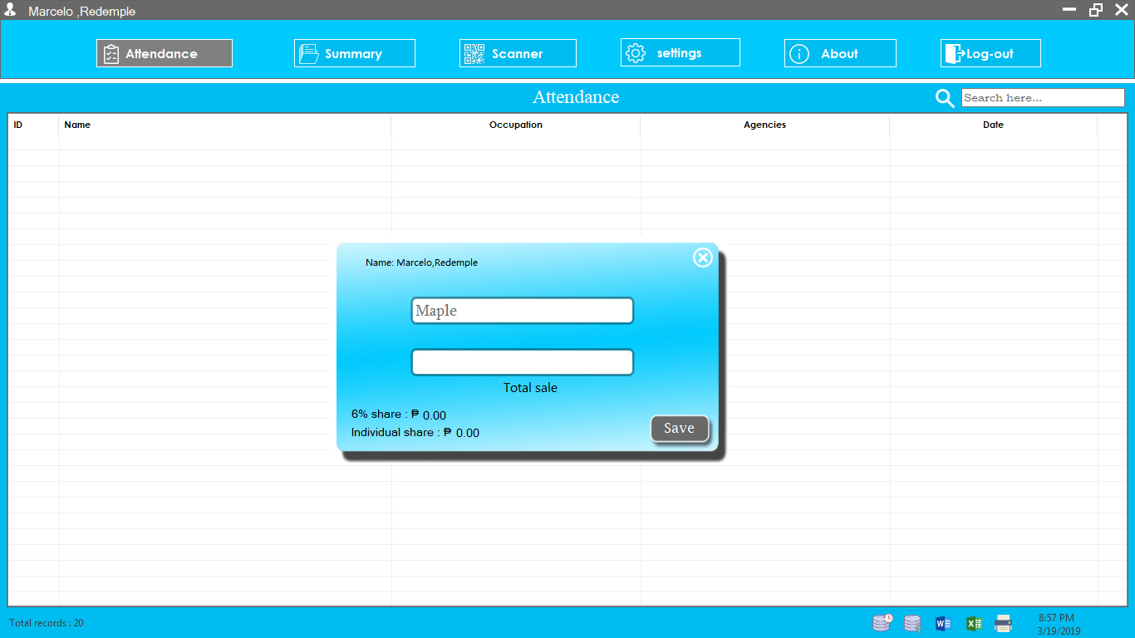

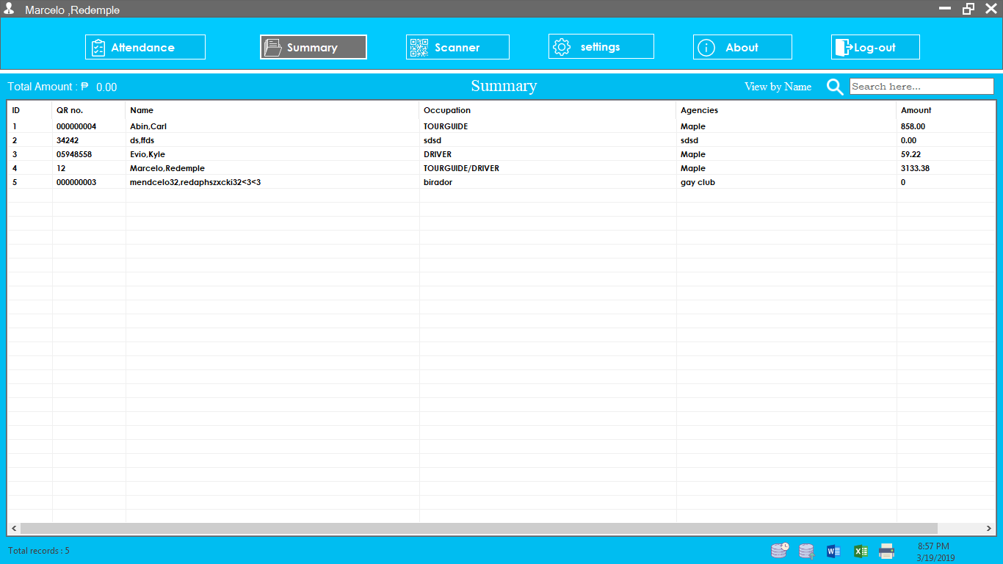**EnterAmount from Attendance**

**Summary of all records**

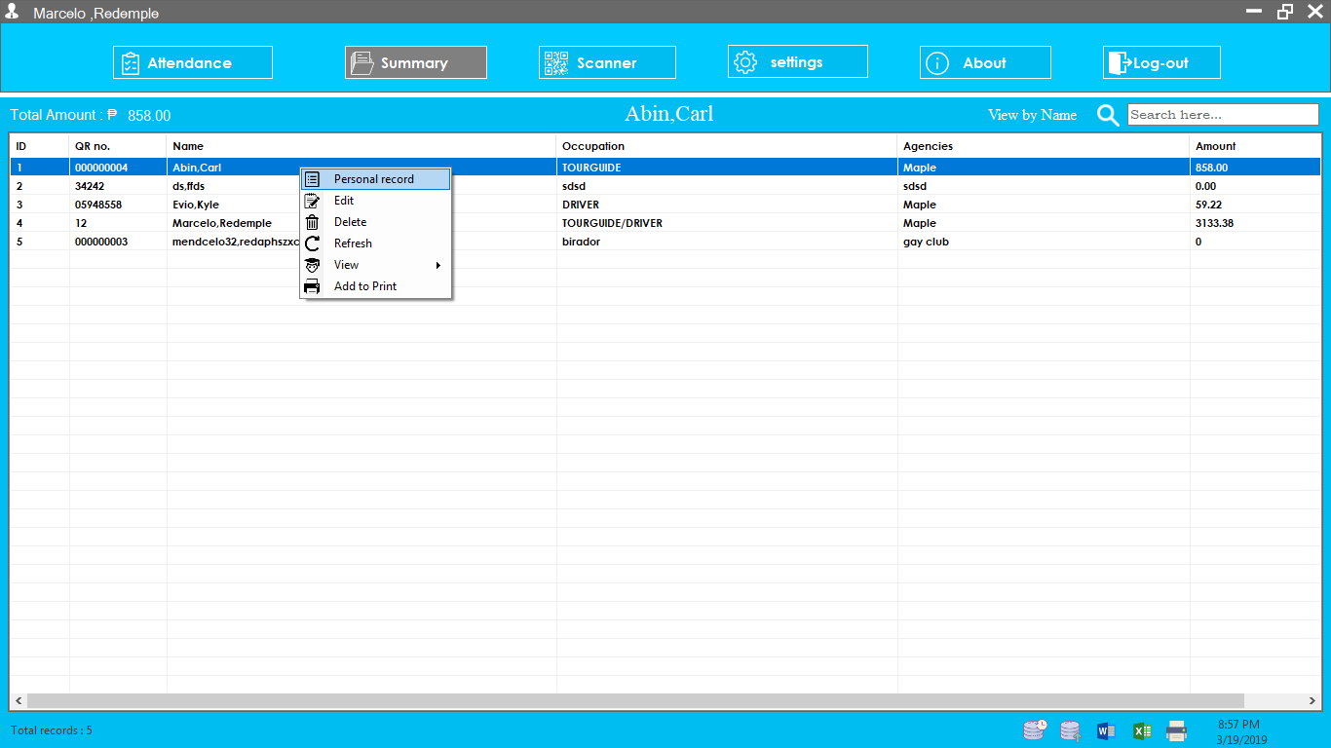

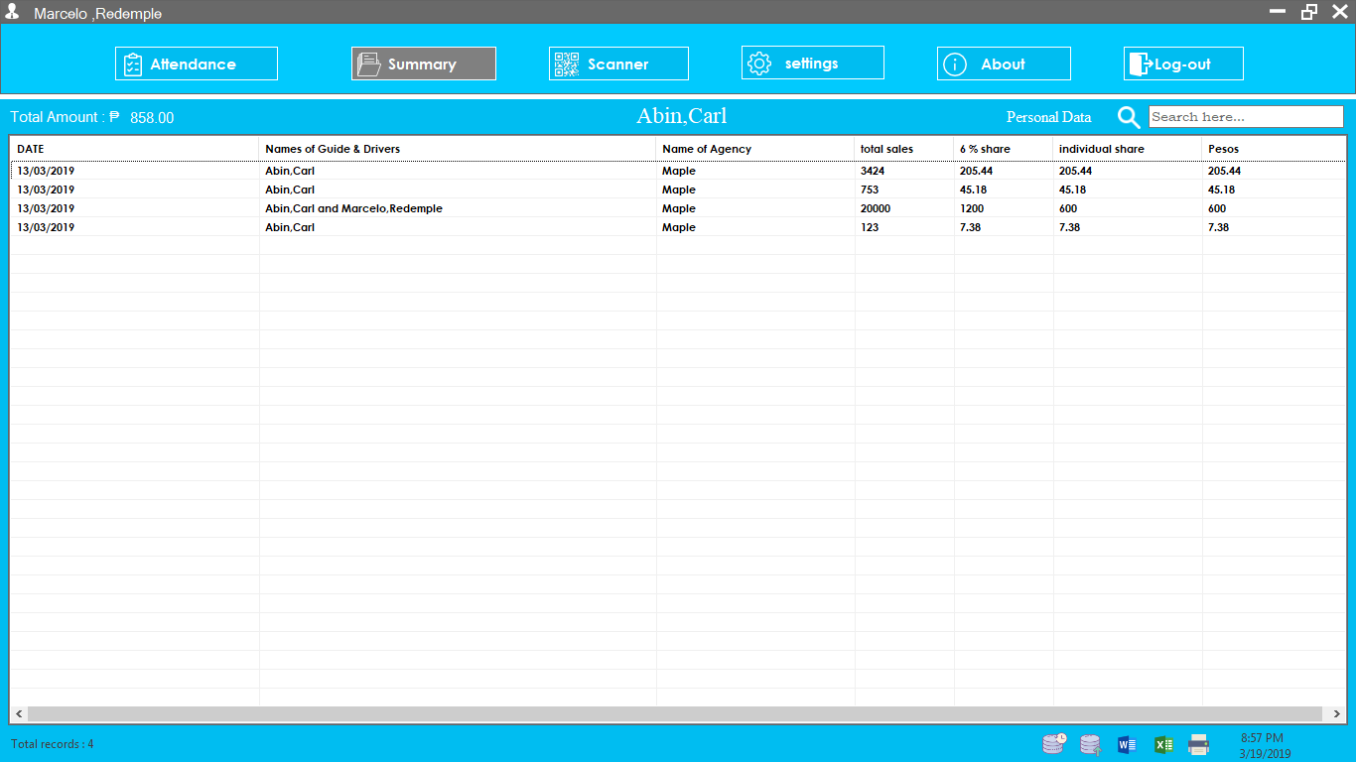

**View Personal record from summary**

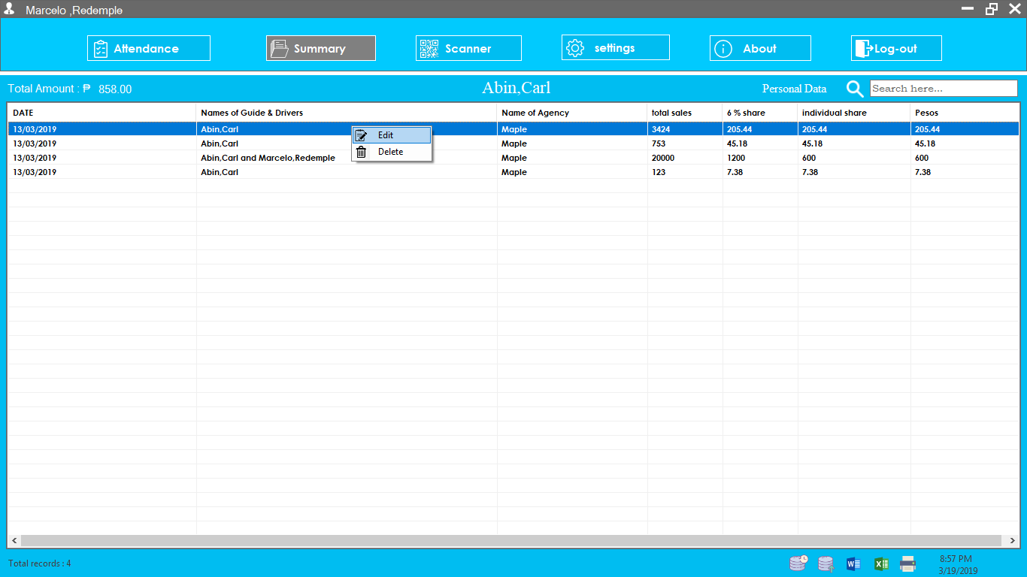

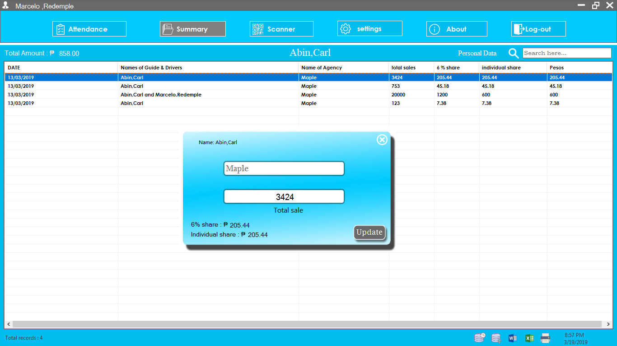

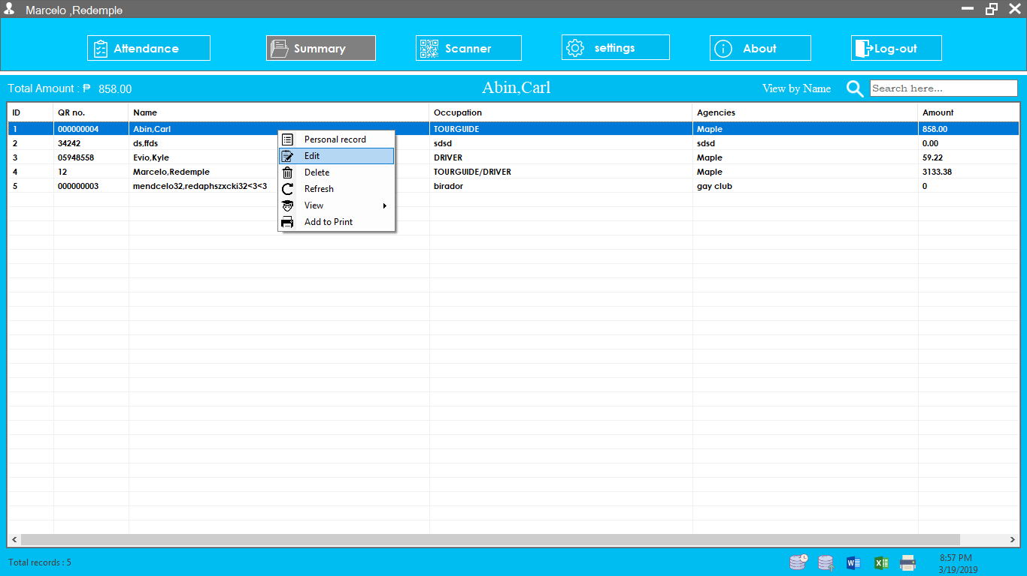**Edit and Delete from Personal record**

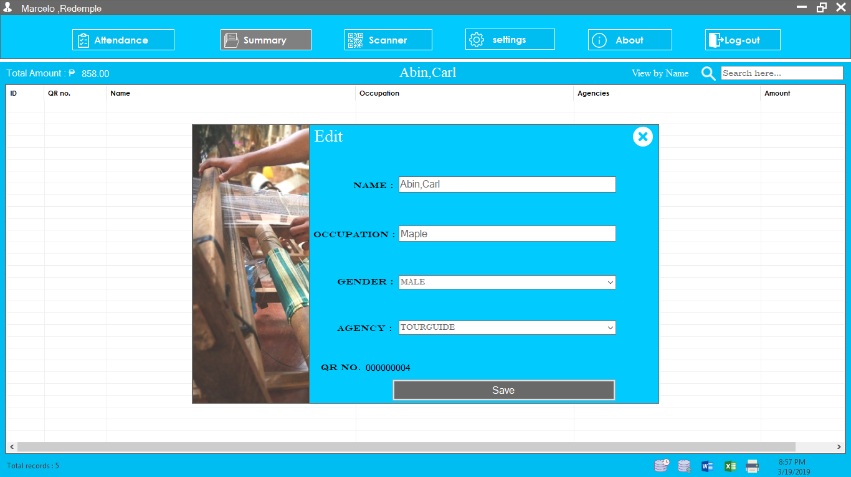

**Edit and Delete from summary**

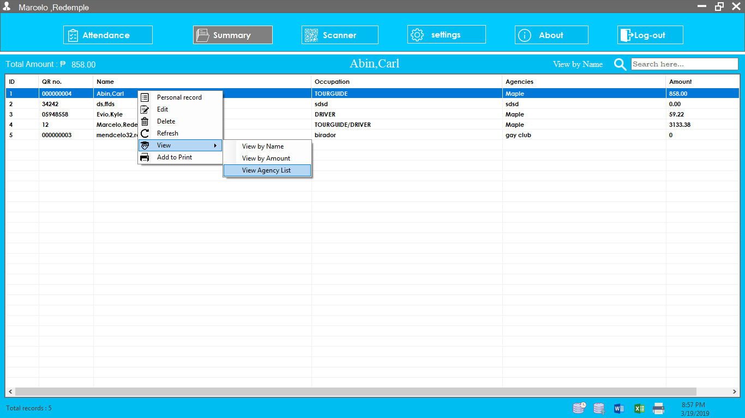

**View summary by ACS Name, ACS Amount and View agency List**

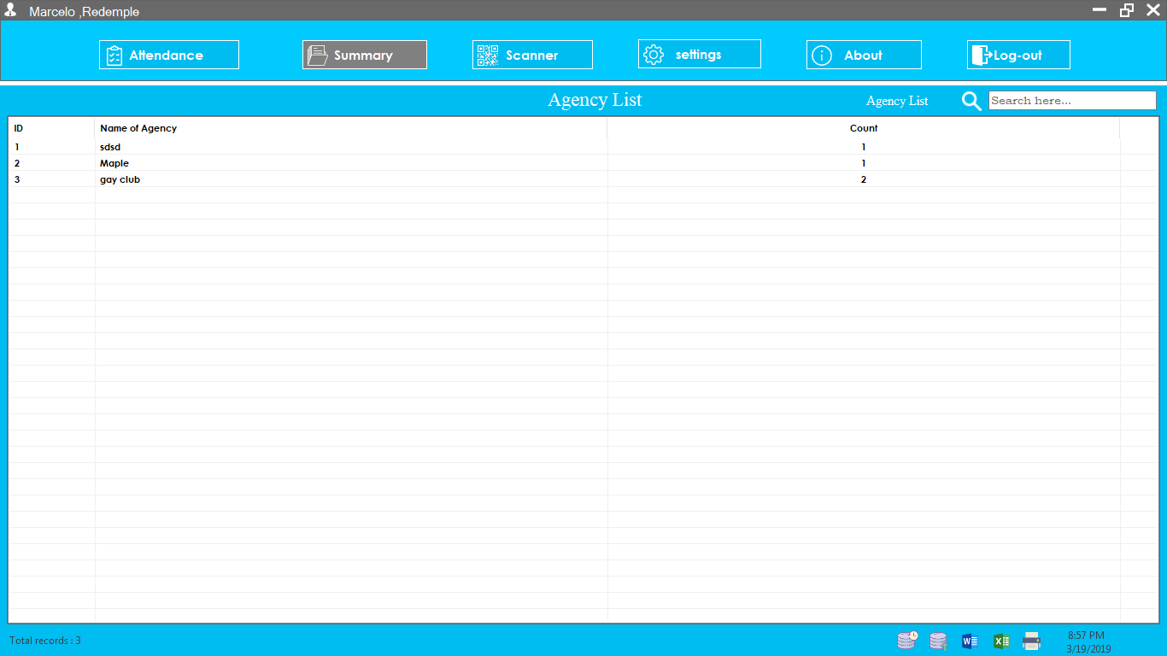

**Agency List**

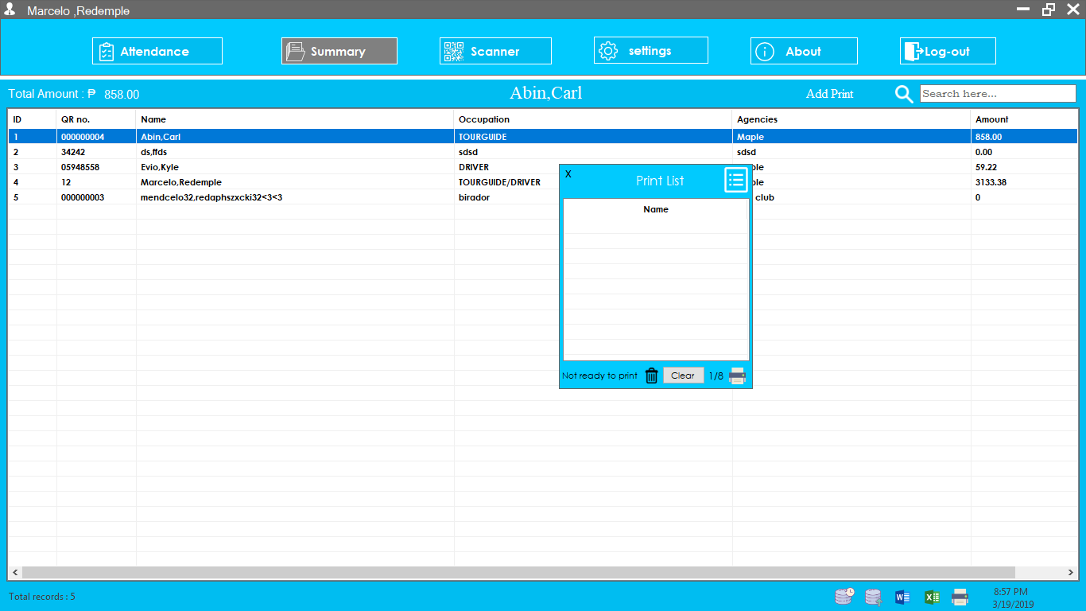

**Add print**

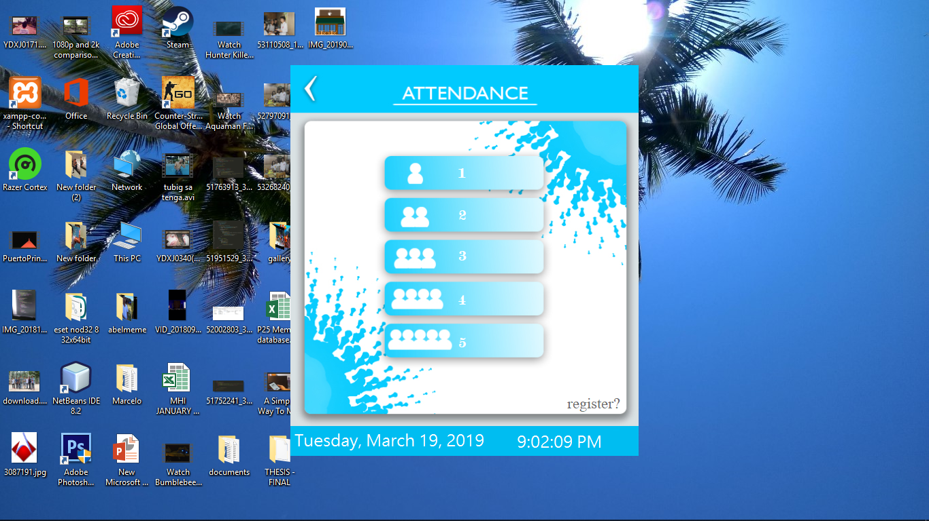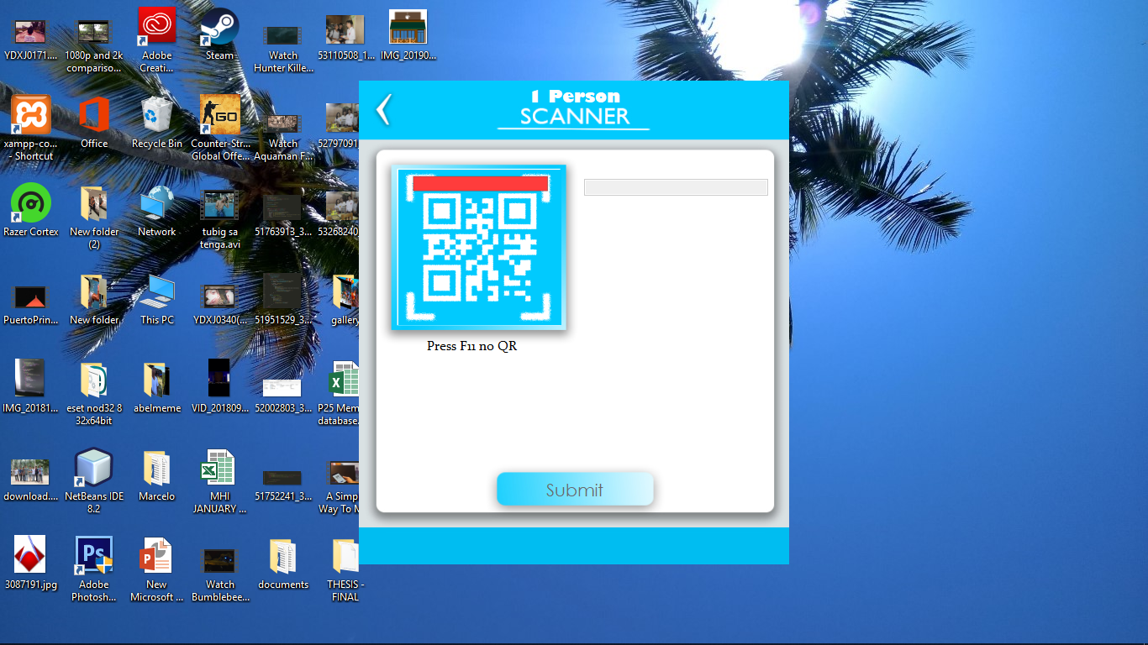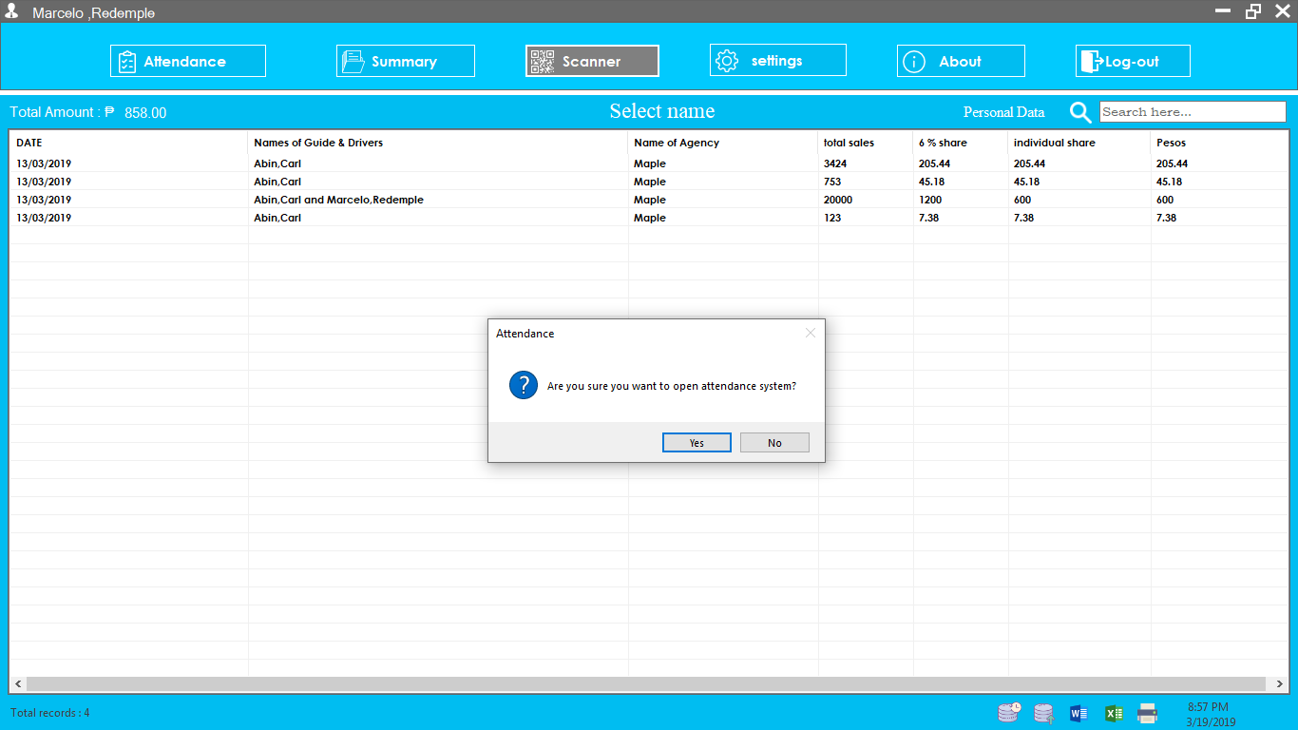

**Open Attendance System**

**Scanner System(attendance)**

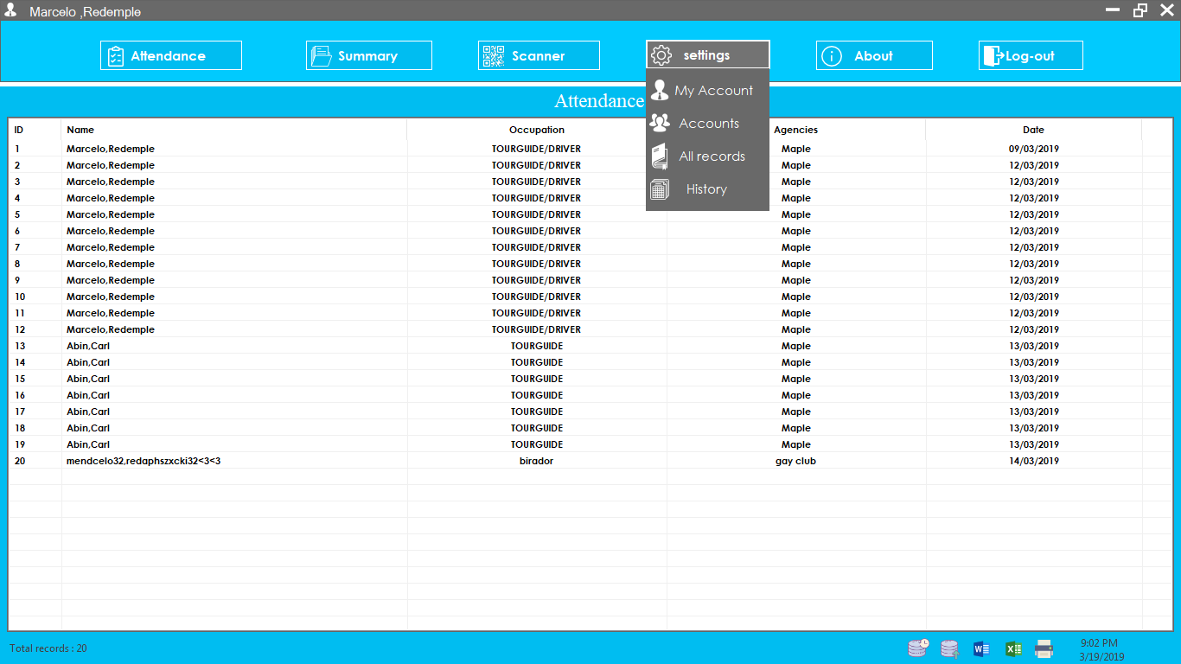

**Settings(My account, Accounts, All records and History)**

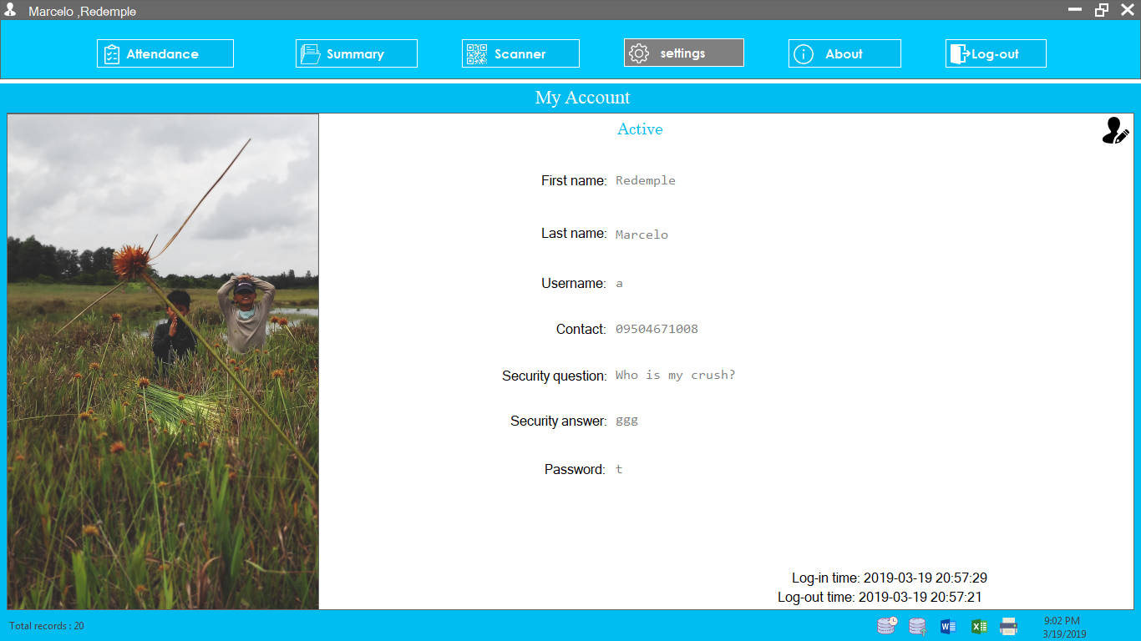

**User account**

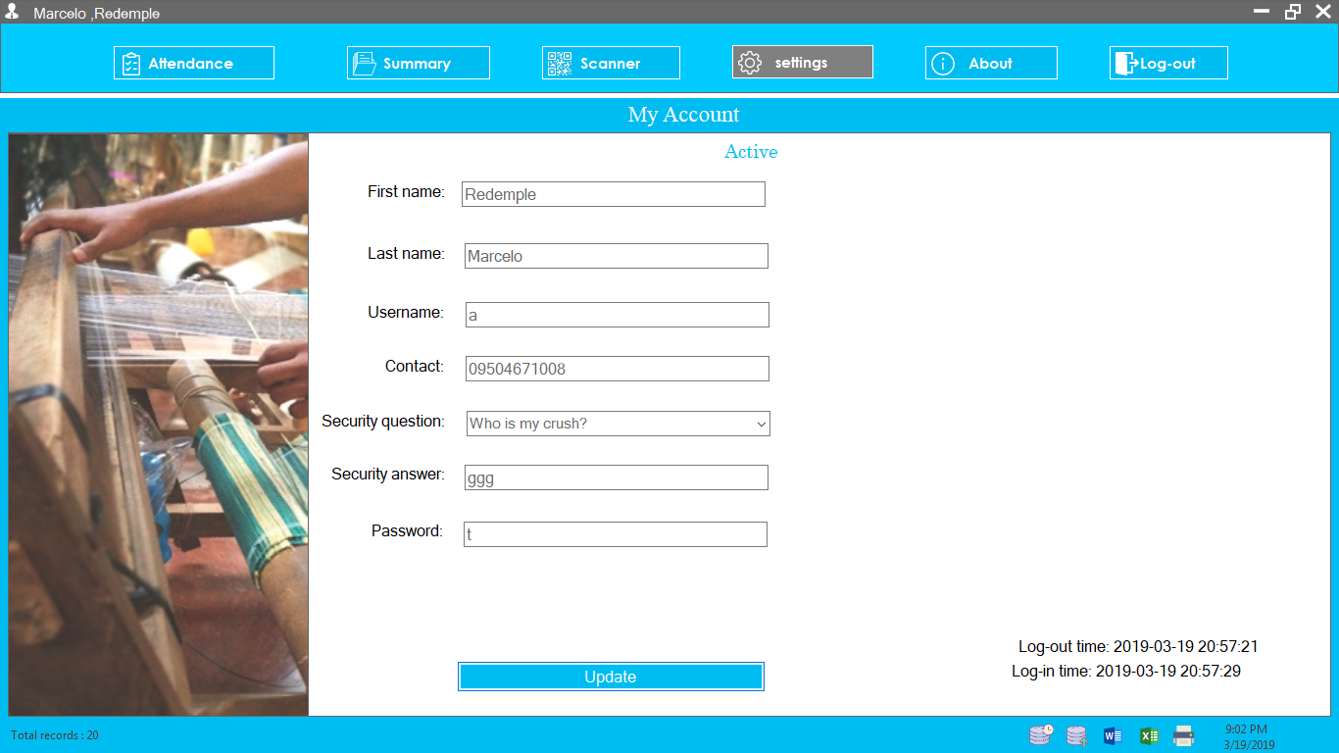

**Edit account**

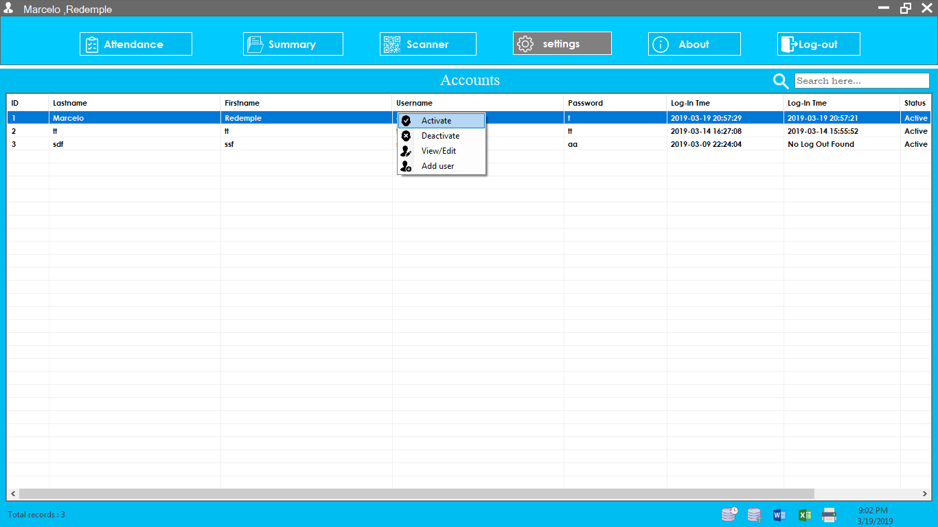

**Account (Activate, Deactivate, View, Edit and User)**

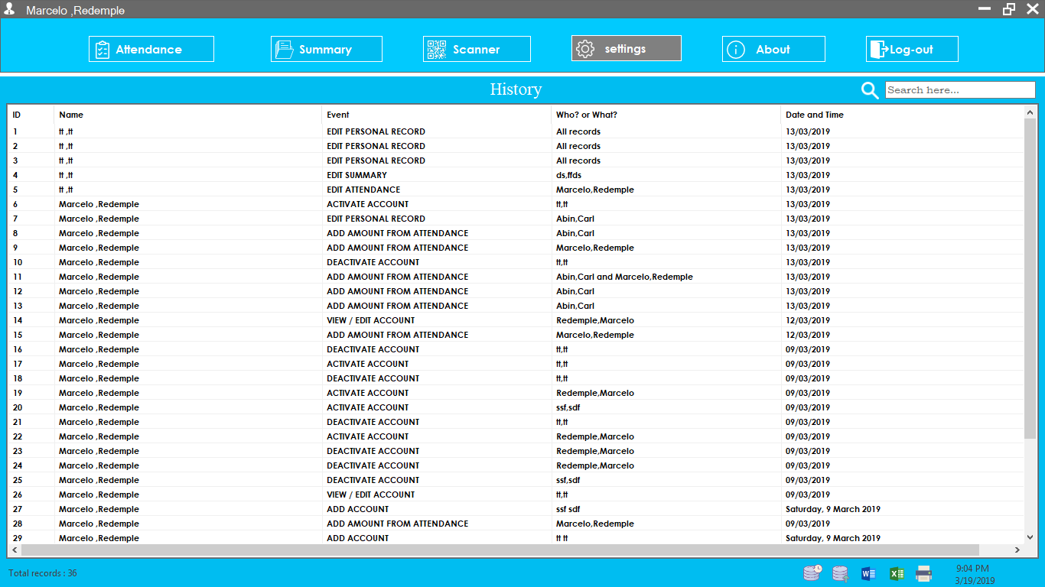

**History**

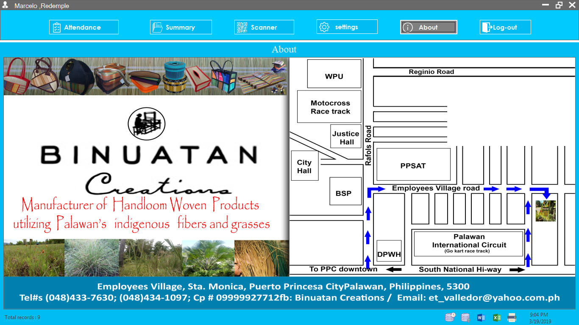

**About**

**APPENDICES B**

**QUESTIONAIRE**

Questionnaire

1. What is the problem when you are using manual system?
2. Does it take long to process the documents? Why?
3. What do you want to happen in terms of Binutan Creations Tour Guides and Drivers Commission System?
4. Why do you want to change the manual method into a system?
5. What is the difference between manual processing and modern technology?
6. How can Computerization System ease work and make faster accomplishment in doing total commission for tour guides and drivers?

**APPENDICES C**

**CURRICULUM VITAE**

NAME: Camilla Bacaltos

NICKNAME: Milay

AGE: 18

GENDER: Female

CIVIL STATUS: Single

DATE OF BIRTH: January 15, 2001

PLACE OF BIRTH: El Nido Palawan

NATIONALITY: Filipino

RELIGION: Roman Catholic

ADDRESS: Bgy. Sta.Lourdes Puerto Princesa City

PARENTS

FATHER: Winefredo Bacaltos

MOTHER: Nelmie Jeruta

EDUCATIONAL BACKGROUND

LEVEL NAME OF SCHOOL SCHOOL YEAR

ELEMENTARY El Nido Central School 2007-2013

SECONDARY El Nido National High School 2013-2017

**APPENDICES C**

**CURRICULUM VITAE**

NAME: John Paul Bautista

NICKNAME: Paul

AGE: 17

GENDER: Male

CIVIL STATUS: Single

DATE OF BIRTH: May 31, 2001

PLACE OF BIRTH: Puerto Princesa City

NATIONALITY: Filipino

RELIGION: Roman Catholic

ADDRESS: Bgy. Tagburos Puerto Princesa City

PARENTS

FATHER: Alley Bautista Jr.

MOTHER: Nora Bautista

EDUCATIONAL BACKGROUND

LEVEL NAME OF SCHOOL SCHOOL YEAR

ELEMENTARY Tagburos Elementary School 2007-2013

SECONDARY San Jose National High School 2013-2017

**APPENDICES C**

**CURRICULUM VITAE**

NAME: Christian Tabang

NICKNAME: Christian

AGE: 18

GENDER: Male

CIVIL STATUS: Single

DATE OF BIRTH: July 03, 2000

PLACE OF BIRTH: Puerto Princesa City

NATIONALITY: Filipino

RELIGION: Roman Catholic

ADDRESS: Bgy. San Jose Puerto Princesa City

PARENTS

FATHER: Ely Tabang

MOTHER: Myra Tabang

EDUCATIONAL BACKGROUND

LEVEL NAME OF SCHOOL SCHOOL YEAR

ELEMENTARY East Central School 2007-2013

SECONDARY Palawan National School 2013-2017

**APPENDICES C**

**CURRICULUM VITAE**

NAME: Efraim Maas

NICKNAME: Efraim

AGE: 18

GENDER: Male

CIVIL STATUS: Single

DATE OF BIRTH: January 03, 2001

PLACE OF BIRTH: Puerto Princesa City

NATIONALITY: Filipino

RELIGION: Iglesia Ni Cristo

ADDRESS: Bgy. San Manuel Puerto Princesa City

PARENTS

FATHER: Randy Maas

MOTHER: Felisedad Maas

EDUCATIONAL BACKGROUND

LEVEL NAME OF SCHOOL SCHOOL YEAR

ELEMENTARY Angels World Academy 2007-2013

SECONDARY Salve Regina School 2013-2017

**APPENDICES C**

**CURRICULUM VITAE**

NAME: Redemple Marcelo

NICKNAME: Redemple/ Ple

AGE: 18

GENDER: Male

CIVIL STATUS: Single

DATE OF BIRTH: July 03, 2000

PLACE OF BIRTH: Puerto Princesa City

NATIONALITY: Filipino

RELIGION: Roman Catholic

ADDRESS: Bgy. Sta.Monica Puerto Princesa City

PARENTS

FATHER: Leonardo Marcelo

MOTHER: Teresita Marcelo

EDUCATIONAL BACKGROUND

LEVEL NAME OF SCHOOL SCHOOL YEAR

ELEMENTARY Bagong Sikat Elementary Schoool 2007-2013

SECONDARY Sta.Monica High School 2013-2017

**APPENDICES D**

**LETTER FOR INTERVIEW**

**AMA COMPUTER LEARNING CENTER**

**ROMASANTA ROAD, BRGY. SAN PEDRO**

**PUERTO PRINCESA CITY,PALAWAN**

October 16, 2018

**Eva T. Valledor**

Manager of Binuatan Creations

Bgy, Sta. Monica, Puero Princesa City

Madam:

Warmest greetings!

I would like to formally ask your permission to allow my students to conduct an interview specifically to the person that holds the patient’s information. The said interview would serve as their data needed for their research study entitled **“Binuatan Creations’ Tour Guides and Drivers Commission System”** as a requirement for the practical research subject. We will assure you that the data or information being gathered is only for our research study purpose only.

Your approval for this letter is highly appreciated. Thank you so much and God bless.

Respectfully Yours,

ANABETH MAGBANUA-CUYOS

Research Instructress